TRAFFIC MANAGEMENT SYSTEM USING INTERNET OF THINGS(IOT)

NAN MUDHALVAN PROJECT REPORT

**PRARTHANA.S (REG NO:610821106074)**

**ELECTRONICS AND COMMUNICATION ENGINEERING**

**ER.PERUMAL MANIMEKALAI COLLEGE OF ENGINEERING**

**NOVEMBER,2023**

**ABSTRACT:**

Over the years, there has been a sudden increase in the number of vehicles on the road. Traffic congestion is a growing problem everyone faces in their daily life. Manual control of traffic by traffic police has not proved to be efficient. Also the predefined set time for the signal at all circumstances (low and high traffic density has not solved this problem. A model to effectively solve the above mentioned problems by using Internet of Things (IoT) is proposed. We use cloud for internet based computing, where different services such as server, storage and application are delivered for traffic management. A network of sensors is used to track the number of vehicles and the traffic congestion at the intersections on a road and rerouting will be done on the basis of the traffic density on the lanes of a road.

Keywords: IoT, Sensors, Microcontroller.

4

**INTRODUCTION:**

HYPOTHESIS:

A smart traffic management system utilizing sensor data, communication and auto-mated algorithms is to be developed to keep traffic flowing more smoothly. The aim is to optimally control the duration of green or red light for a specific traffic light at an intersection. The traffic signals should not flash the same stretch of green or red all the time, but should depend on the number of cars present. When traffic is heavy in one direction, the green lights should stay on longer; less traffic should mean the red lights should be on for longer time interval. This solution is expected to eliminate inefficiencies at intersections and minimize the cost of commuting and pollution.

MOTIVATION:

In 2014, 54% of the total global population was urban residents. The prediction was a growth of nearly 2% each year until 2020 leading to more pressure on the transportation system of cities. Additionally, the high cost of accommodation in business districts lead to urban employees living far away from their place of work/education and therefore having to commute back and forth between their place of residence and their place of work. More vehicles moving need to be accommodated over a1 fixed number of roads and transportation infrastructure. Often, when dealing with increased traffic, the reaction is just widen the lanes or increase the road levels. However, cities should be making their streets run smarter instead of just making them bigger or building more roads. This leads to the proposed system which will use a micro controller and sensors for tracking the number of vehicles leading to time based monitoring of the system.(Babu, 2016)

PROJECT OBJECTIVES:

The objectives of a traffic management project typically include:

1. Improve Traffic Flow: Enhance the overall flow of vehicular and pedestrian traffic to reduce congestion and minimize delays.
2. Increase Safety: Implement measures to reduce accidents and enhance road safety for all road users.
3. Reduce Environmental Impact: Minimize emissions and environmental impact through efficient traffic management strategies.
4. Optimize Infrastructure: Ensure efficient use of road infrastructure by implementing measures such as signal synchronization, lane management, and intelligent transportation systems.
5. Enhance Public Transportation: Promote the use of public transportation and develop infrastructure for buses, trams, and other mass transit options.
6. Provide Real-Time Information: Offer real-time traffic updates and information to drivers and commuters to help them make informed decisions.
7. Support Emergency Services: Ensure quick and efficient access for emergency services in the event of accidents or disasters.
8. Promote Sustainable Transportation: Encourage walking, cycling, and other eco-friendly modes of transportation.
9. Manage Special Events: Handle traffic management for special events, construction, and road closures effectively.
10. Public Engagement and Education: Educate the public about safe driving practices and the benefits of the traffic management initiatives.
11. Data Collection and Analysis: Continuously collect and analyze traffic data to adapt and improve traffic management strategies.

These objectives can vary depending on the specific goals and challenges of a given traffic management project.

IOT SENSOR SETUP:

A traffic management project using IoT sensor setup typically involves deploying various sensors and devices to monitor and manage traffic flow and congestion in real-time. Here's a general overview of such a project:

1. Sensor Deployment: IoT sensors, such as cameras, ultrasonic sensors, infrared sensors, and vehicle detectors, are strategically placed at key locations throughout the city or on specific roadways. These sensors can detect various parameters, including vehicle presence, speed, and traffic density.
2. Data Collection: The sensors continuously collect data and transmit it wirelessly to a central server or cloud platform. This data includes information about traffic conditions, such as the number of vehicles, vehicle types, and their speeds.
3. Data Processing: The collected data is processed and analyzed in real-time. Machine learning algorithms can be employed to predict traffic patterns, identify congestion points, and analyze traffic trends.
4. Traffic Management: Traffic authorities can access the processed data through a user-friendly interface, enabling them to make informed decisions. They can adjust traffic signals, update electronic road signs, or dispatch traffic personnel to address congestion and incidents promptly.
5. Communication and Alerts: IoT sensors can also be used to send alerts to drivers through variable message signs, mobile apps, or navigation systems, providing real-time information about traffic conditions and suggesting alternative routes.
6. Environmental Monitoring: Some IoT setups may include environmental sensors to monitor air quality and emissions, contributing to a holistic approach to traffic management and urban planning.
7. Integration with Smart Systems: In more advanced setups, the traffic management project can integrate with other smart city systems, such as smart street lighting, public transportation, and emergency services, to further optimize traffic flow.
8. Data Storage and Analytics: Collected data is often stored for historical analysis, helping authorities make long-term decisions related to infrastructure improvements, road expansions, and urban planning.
9. Cost and Efficiency Benefits: By reducing congestion, improving traffic flow, and decreasing fuel consumption and emissions, IoT-based traffic management projects can have significant economic and environmental benefits for a city.
10. Public Engagement: Citizen engagement can be enhanced through public access to real-time traffic data and participation in smart city initiatives, ultimately leading to more informed and satisfied communities.

IoT sensor setups for traffic management are a vital component of smart city initiatives, helping to alleviate traffic congestion, enhance safety, and create more efficient urban environments.

MOBILE APP DEVELOPMENT:

Developing a traffic management project mobile app involves creating a software application that assists in managing and optimizing traffic flow, safety, and information for users. Here are the key aspects involved:

**User Interface (UI):** The app should have an intuitive and user-friendly interface for easy navigation. It should include maps, icons, and menus for various functions.

**Real-time Data:** The app needs to access and display real-time data, such as traffic conditions, accidents, road closures, and weather updates. This data can be sourced from various sensors, cameras, and traffic agencies.

**GPS Integration:** Utilize GPS to provide users with their current location, turn-by-turn navigation, and real-time traffic updates. Users should also be able to plan routes based on traffic conditions.

**Traffic Alerts:** Implement a notification system to alert users about accidents, road closures, or severe congestion on their routes, allowing them to choose alternatives.

**Live Cameras:** Include live traffic cameras at key locations to give users a visual perspective of current traffic conditions.

**Traffic Management Tools:** For authorities, include tools for monitoring and managing traffic. This could involve adjusting traffic signals, coordinating with law enforcement, or implementing emergency plans.

**User-Generated Content:** Allow users to report incidents, accidents, and road conditions. These reports can be shared with other users to increase awareness.

**Integration with Other Services:** Integrate the app with public transportation information, ride-sharing services, and parking availability to offer comprehensive commuting solutions.

**Emergency Services Integration:** Provide quick access to emergency services and first responders in case of accidents or emergencies.

**Analytics and Reporting:** For traffic agencies, incorporate data analytics and reporting features to track and analyze traffic patterns, enabling better decision-making.

**Security:** Ensure data security and privacy for users and traffic authorities, especially when collecting and sharing sensitive information.

**Scalability:** Design the app to handle a large user base and the potential for increased data traffic during peak times.

**Compatibility:** Develop versions of the app for various mobile platforms (iOS and Android) to reach a broader audience.

**Regulatory Compliance:** Ensure that the app complies with local traffic regulations and data protection laws.

**Testing and Quality Assurance:** Rigorously test the app for stability, performance, and accuracy of real-time data before its release.

**Feedback Mechanism:** Implement a feedback system to collect user opinions and suggestions for continuous improvement.

**Maintenance and Updates:** Regularly update the app to keep it current and improve its functionality based on user feedback and evolving traffic conditions.

Development teams often consist of UI/UX designers, mobile app developers, database specialists, and data analysts. The success of a traffic management project mobile app depends on effective collaboration between the relevant transportation authorities and the development team to ensure accurate data and seamless functionality.

RASPBERRY PI INTEGRATION:

Integrating Raspberry Pi into a traffic management project involves using the Raspberry Pi as a versatile and cost-effective controller for various traffic-related tasks. Here's a general overview of how it can be done:

**Hardware Setup:**

Raspberry Pi board: Select an appropriate Raspberry Pi model with the required processing power and connectivity options.

Camera Module: Attach a compatible camera module for image and video capture.

Sensors: Connect sensors (e.g., ultrasonic, infrared) to detect vehicles and pedestrians.

LED Displays: Interface LED displays or traffic lights for signaling.

**Software Development:**

Operating System: Install a Linux-based OS on the Raspberry Pi, such as Raspbian (now Raspberry Pi OS).

Programming: Develop software using programming languages like Python or C/C++.

Image Processing: Implement image processing algorithms to analyze traffic conditions.

Data Analysis: Collect and process data from sensors and cameras.

Communication: Establish communication protocols for sending/receiving data to/from central servers or other devices.

**Traffic Monitoring:**

Vehicle Detection: Use the camera and sensors to detect and count vehicles.

Traffic Flow Analysis: Analyze vehicle speed and density for traffic flow monitoring.

License Plate Recognition: Implement license plate recognition for security and traffic enforcement.

**Traffic Control:**

Traffic Signal Control: Adjust traffic signals based on real-time traffic conditions.

Dynamic Lane Management: Control lane direction or usage as needed.

Emergency Response: Automatically respond to emergencies by changing traffic patterns.

**Data Reporting:**

Data Visualization: Create graphical representations of traffic data.

Remote Access: Enable remote monitoring and control via web interfaces or apps.

Data Storage: Store historical data for analysis and decision-making.

**Integration with Other Systems:**

IoT Connectivity: Integrate with Internet of Things (IoT) platforms for seamless data sharing.

Cloud Integration: Upload data to the cloud for further analysis and long-term storage.

**Safety and Redundancy:**

Implement safety mechanisms to handle unexpected events or failures.

Ensure redundancy in critical components to maintain system operation.

**Testing and Calibration:**

Thoroughly test the system in various traffic scenarios.

Calibrate sensors and cameras for accuracy.

**Maintenance and Updates:**

Regularly update the software to fix bugs and improve performance.

Perform routine maintenance to ensure the system's reliability.

**Compliance and Regulations:**

Ensure the project adheres to local traffic regulations and safety standards.

Integrating a Raspberry Pi into a traffic management project offers flexibility, affordability, and the potential for real-time monitoring and control. However, it's important to carefully plan and implement the project to ensure its effectiveness and reliability.

**CODE IMPLEMENTATION:**

Implementing a traffic management project using Python involves various components, including data collection, analysis, and control. Here's a high-level overview of the steps and components you might consider:

1. **Data Collection**:
   * Use sensors, cameras, or APIs to collect real-time traffic data, such as vehicle counts, speed, and congestion.
2. **Data Processing**:
   * Process and store the collected data in a database, such as SQLite or MySQL, for analysis and decision-making.
3. **Data Analysis**:
   * Use Python libraries like Pandas and NumPy to analyze the traffic data to identify patterns and congestion points.
4. **Visualization**:
   * Utilize libraries like Matplotlib or Plot to create visualizations like traffic heatmaps, real-time traffic flow maps, and congestion alerts.
5. **Machine Learning (Optional)**:
   * Implement machine learning models to predict traffic patterns or congestion, allowing for proactive management.
6. **Traffic Control**:
   * Depending on the scale and resources, you can control traffic lights or signals in real-time. Use libraries like RPi,GPIO if you're working with Raspberry Pi.
7. **User Interface**:
   * Create a user interface for monitoring and controlling traffic. You can use web frameworks like Flask or Django for this.
8. **Communication**:
   * Establish communication with traffic control systems using protocols such as MQTT or HTTP for remote management.
9. **Alerting System**:
   * Implement an alerting system to notify authorities or the public about traffic incidents or congestion.
10. **Testing and Simulation**:
    * Simulate the traffic management system to test its effectiveness and identify any issues.
11. **Deployment**:
    * Deploy the system in a real-world environment, ensuring it's robust and reliable.
12. **Maintenance and Monitoring**:
    * Regularly update and monitor the system for any issues or updates.

Here's a simple example of Python code to get you started with traffic data analysis using Pandas:

Python code

import pandas as pd

# Load traffic data from a CSV file

traffic_data = pd.read_csv('traffic_data.csv')

# Analyze the data, e.g., calculate average speed

average_speed = traffic_data['speed'].mean()

# Visualize the data

import matplotlib.pyplot as

plt

traffic_data. Plot x='timestamp', y='speed')

plt.xlabel('Time')

plt.ylabel('Speed')

plt.title('Traffic Speed Over Time')

plt.show()

Remember, the implementation can be much more complex based on the scale and requirements of your project. You may also need to integrate with hardware and external systems for traffic control.

**DIAGRAMS,SCHEMATICS AND SCREENSHOTS OF IOT SENSOR:**

**REQUIREMENTS**

**Hardware Components**

1. Microcontroller (Raspberry pi Mega 2560): The Raspberry pi Mega 2560 is a

micro- controller board based on the At mega 2560. It has 54 digital input/output pins (of which 15 can be used as PWM outputs), 16 analog inputs, 4 UARTs(hardware serial ports), a 16 MHz crystal oscillator, a USB connection, a power jack, an ICSP header, and a reset button. It contains everything needed to support the microcontroller; simply connect it to a computer with a USB cable or power it with a AC-to-DC adapter or battery to get started. The Mega 2560 board is compatible with most shields designed for the Extension board and the former boards.

RASPBERRY PI:

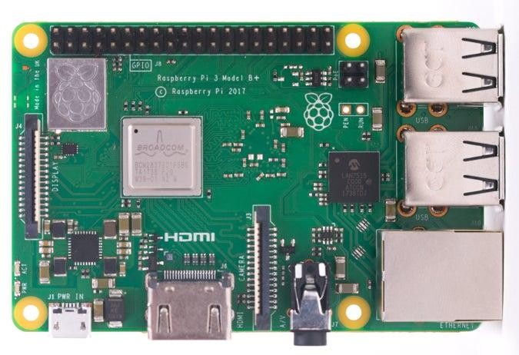

1. **Microcontroller (Raspberry pi)**: The Raspberry pi is an open-source micro- controller board based on the Microchip ATmega328Pmicrocontroller and developed by Arduino.cc. The board is equipped with sets of digital and analog input/output (I/O) pins that may be interfaced to various expansion boards (shields) and other circuits. The board has 14 Digital pins, 6 Analog pins, and programmable with the Raspberry pi IDE (Integrated Development Environment) via a type B USB cable.

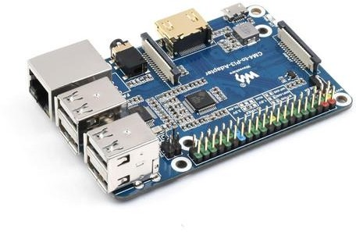

1. **LEDs**: LEDs are used for the purpose of signaling according to the traffic condition.



LED for Traffic Lights.

1. **IR Sensor**: IR Sensor is used to count the vehicles on the road.

10

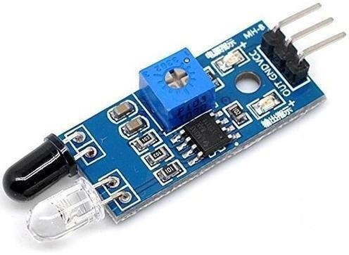

IR Sensors.

1. **Jumper Wires**: It is used to connect the components to each other.

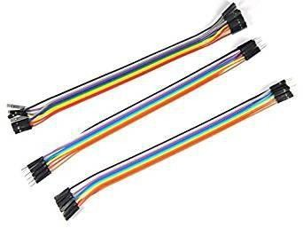

### Requirements Software Requirement

1. **Raspberry pi IDE**: The Raspberry pi integrated development environment (IDE) is a cross-platform application (for Windows, MacOS, Linux) that is written in the programming language Java. It is used to write and upload programs to Raspberry pi board.

The source code for the IDE is released under the GNU General Public License, version 2. The Raspberry pi IDE supports the languages C and C++ using special rules of code structuring. The Raspberry pi IDE supplies a software library from the Wiring project, which provides many common input and output procedures.

1. **Proteus Design Suite**: The Proteus Design Suite is a proprietary software tool suite used primarily for electronic design automation. The software is used mainly by electronic design engineers and technicians to create schematics and electronic prints for manufacturing printed circuit boards.

### Method:

In this proposed system, the traffic lights are LEDs and the car counting sensor is an ultrasonic sensor. Both blocks are connected to a Microcontroller using physical wires. The Microcontroller is the traffic light controller which receives the collected sensor data and manages the traffic lights by switching between green, yellow and red. The Microcontroller computes the number of cars in the street of the inter- section it is monitoring based on the distances measured by the ultrasonic sensor and the timing between those measurements. The Microcontroller then sends the number of cars every minute to the local server. This communication is done using the Microcontroller serial port. The local server exchanges the data received with the cloud server in order to better predict the changes in timings of the traffic light. This communication is done using Wi-Fi. More specifically, the cloud server uses an equation that takes the data received (number of cars) as input then determines the time interval of LEDs needed for a smooth traffic flow. This calculated time is then compared to the current actual time of the LEDs (this data is saved in a database on the cloud server). The server then comes up with a decision. If the current actual green time is less than the calculated time, the decision is to increase the green time, else to decrease the green time.

**View of signals at different lanes:**

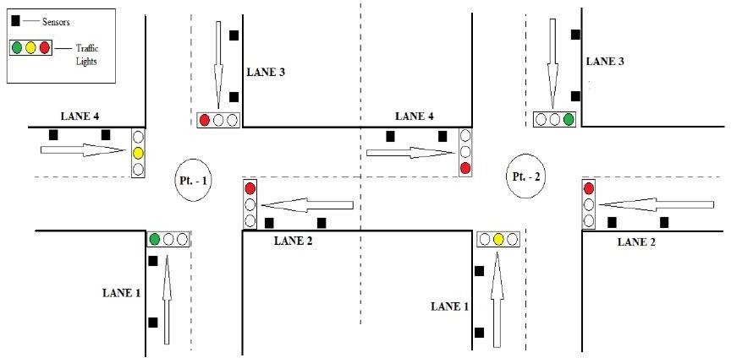

Control of previous Intersection

In the above figure, in Pt. - 1, LANE 1 is currently open with green signal and LANE 4 is ready with yellow signal but LANE 2 and LANE 3 are blocked. In LANE 3, vehicle count is already greater than the threshold value, therefore the road coming to LANE 2 of Pt. - 1 is blocked in the Pt. - 2 itself. Thus re-routing them through another lanes. (Assuming that Pt. - 1 is the current intersection and Pt. - 2 is the previous intersection.)

Sequence diagram:

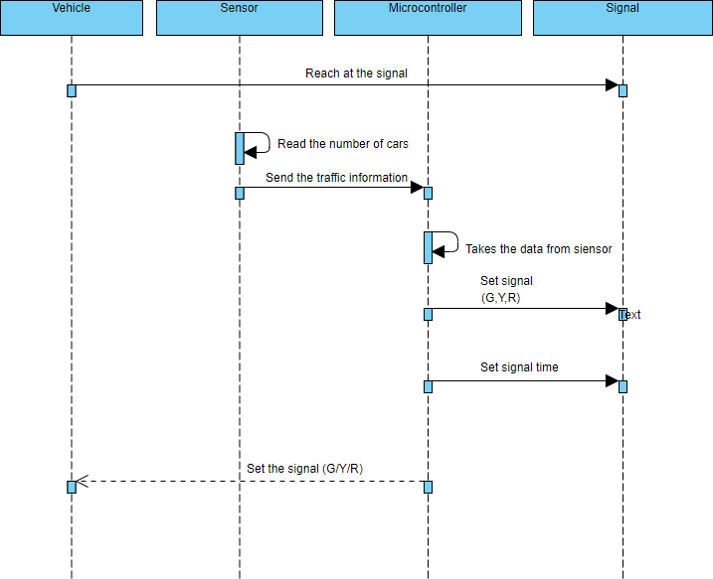

Case diagram:

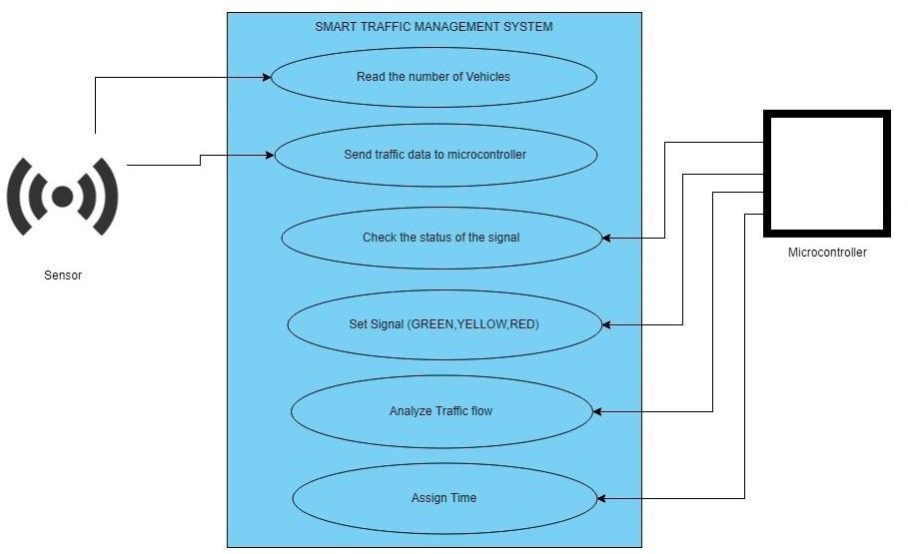

### Counter algorithm:

Assuming the objects detected by the IR Sensors to be vehicles, int counter = 0;

int hit Object = false;

int val;

step 1;Read value from sensor.

**Step 2:** If val == 0 hit Object = false then increment the counter and set hit object

= true.

else if val == 1 hit Object = true then set hit Object = false.

**Step 3:** Go to step 1

#### **TRAFFIC CONTROL ALGORITHM**

No. of sensors = 8 and are denoted by S1, S2, S3, S4, S5, S6, S7, S8 No. of cars in Lane 1 (N1) = S1 – S2

No. of cars in Lane 2 (N2) = S3 – S4 No. of cars in Lane 3 (N3) = S5 – S6 No. of cars in Lane 4 (N4) = S7 – S8

Li = (L1, L2, L3, L4), Ni = (N1, N2, N3, N4), Ti = (T1, T2, T3, T4)

**Step 1:** Start

**Step 2:** Sensors will read the no. of vehicles on each lane (i.e. L1, L2, L3, L4)

**Step 3:** if (Vehicle Count *<* Threshold)

Then status = Normal traffic. Turn on the green signal for all the lanes one after another in a sequential manner (L1-L2-L3-L4). When signal is green for one lane,the others will remain red.

**Step 4:** else status = congestion.

**Step 5:** COMPARE (N1, N2 , N3, N4), Select the highest of the four (say Ni),turn on green signal for that lane (say Li) for time (Ti). When time Ti ends, turn on the red signal.

**Step 6:** COMPARE (N2, N3, N4), Select the highest of the three (say Ni), turn on green signal for that lane (say Li) for time (Ti). When time Ti ends, turn on the red signal.

**Step 7:** COMPARE (N3, N4), Select the highest of the two (say Ni), turn on green signal for that lane (say Li) for time (Ti). When time Ti ends, turn on the red signal.

**Step 8:** The last remaining lane automatically gets selected and it is given the green signal for time Ti.

**Step 9:** Jump to Step 3.

**REAL TIME TRAFFIC MONITORING SYSTEM CAN ASSIST COMMUTERS IN MAKING OPTIMAL ROUTE DECISIONS AND IMPROVING TRAFFIC FLOW**:

Real-time Data Updates: These systems provide up-to-the-minute traffic information, including accidents, road closures, and congestion. Commuters can access this data through mobile apps or in-vehicle navigation systems to make informed decisions.

Route Recommendations: The system can suggest alternate routes to avoid heavy traffic, accidents, or road closures, helping commuters find the fastest and least congested path to their destination.

Traffic Predictions: By analyzing historical and real-time traffic data, the system can predict traffic patterns, allowing commuters to plan their trips during off-peak hours to reduce congestion and travel time.

Reducing Bottlenecks: Commuters who receive real-time traffic information can spread out on various routes, reducing congestion on specific roadways and preventing traffic bottlenecks.

Public Transit Integration: Some systems also integrate with public transportation options, allowing commuters to switch to buses or trains when traffic is particularly heavy, further reducing road congestion.

Improved Traffic Flow: By distributing traffic across multiple routes, the system helps to improve overall traffic flow, reducing stop-and-go conditions and preventing gridlock.

Emergency Response: In case of accidents or emergencies, the system can alert emergency services and reroute traffic, facilitating quicker responses and minimizing the impact on overall traffic flow.

Environmental Impact: Reduced congestion and more efficient routing can lead to lower fuel consumption and emissions, contributing to a more environmentally friendly transportation system.

Data-Driven Planning: Traffic monitoring systems generate valuable data for city planners and transportation authorities, helping them make informed decisions about infrastructure improvements and traffic management.

In summary, a real-time traffic monitoring system assists commuters in making optimal route decisions by providing current traffic information and route recommendations, ultimately leading to improved traffic flow, reduced travel time, and a more efficient transportation network.

**Conclusion:**

Smart Traffic Management System has been developed by using multiple features of hardware components in IoT. Traffic optimization is achieved using IoT platform for efficient utilizing allocating varying time to all traffic signal according to available vehicles count in road path. Smart Traffic Management System is implemented to deal efficiently with problem of congestion and perform re-routing at intersections on a road. This research presents an effective solution for rapid growth of traffic flow particularly in big cities which is increasing day by day and traditional systems have Some limitations as they fail to manage current traffic effectively. Keeping in view the state of the art approach for traffic management systems, a smart traffic man- agreement system is proposed to control road traffic situations more efficiently and effectively. It changes the signal timing intelligently according to traffic density on the particular roadside and regulates traffic flow by communicating with local server more effectively than ever before. The decentralized approach makes it optimized and effective as the system works even if a local server or centralized server has crashed. The system also provides useful information to higher authorities that can be used in road planning which helps in optimal usage of resources.

PROJECT SUBMISSION PART:

**Replicate Traffic Management Project**

Replicating a traffic management project is a complex task that can vary significantly depending on the specific goals and technologies involved. However, I can provide a general outline of the steps involved:

1. **Define Project Goals:** Clearly define the objectives of your traffic management project. Do you want to reduce congestion, improve safety, or enhance traffic flow?
2. **Gather Data:** Collect data on traffic patterns, such as vehicle counts, speed, and congestion points. You may use sensors, cameras, or data from government sources.
3. **Select Technology:** Choose the appropriate technology for your project, such as traffic lights, cameras, sensors, or intelligent traffic management systems.
4. **Data Analysis:** Analyze the collected data to identify traffic patterns, congestion areas, and potential areas for improvement.
5. **Algorithm Development:** Develop algorithms to manage traffic based on the data analysis. This may involve optimizing traffic signal timings or controlling variable message signs.
6. **Hardware Implementation:** Install the necessary hardware, such as traffic lights, sensors, cameras, and communication infrastructure.
7. **Software Development:** Create the software to control and manage the hardware components, integrating data analysis and algorithms for real-time traffic management.
8. **Testing and Validation:** Thoroughly test the system to ensure it functions as expected. Simulate different traffic scenarios to validate its effectiveness.
9. **Deployment:** Deploy the traffic management system in the target area, whether it's a single intersection or an entire city.
10. **Monitoring and Maintenance:** Continuously monitor the system's performance and make necessary adjustments. Regular maintenance is crucial to keep the system running smoothly.
11. **User Education:**Educate drivers and the public about the new traffic management system to ensure they understand how it works and how it benefits them.
12. **Data Management and Analysis:** Continue to collect and analyze traffic data to fine-tune the system and adapt to changing traffic patterns.
13. **Feedback and Optimization:** Gather feedback from users and stakeholders and use it to optimize the system further.
14. **Compliance and Regulations:** Ensure that your project complies with local traffic regulations and safety standards.
15. **Scale and Expand (if applicable):** If the project is successful, consider expanding it to other areas or intersections.

Keep in mind that replicating a traffic management project can be a substantial undertaking, and it often involves collaboration with traffic engineers, local authorities, and technology experts. The specific technologies and methodologies used can vary greatly based on the project's scope and budget.

# **Transit Information Platform Development**

Developing a transit information platform as part of a traffic management project involves several key components and considerations:

1. **Data Collection and Integration:** Gather data from various sources, including traffic cameras, sensors, GPS devices, and public transportation systems. This data should be integrated into a centralized database.
2. **Real-Time Monitoring:** Implement real-time monitoring of traffic conditions, including congestion, accidents, and road closures. This data will help commuters make informed decisions.
3. **Public Transportation Integration:** Integrate public transportation data, including bus and train schedules, real-time location information, and ticketing systems.
4. **User-Friendly Interfaces:** Develop user-friendly interfaces, such as web and mobile apps, to provide commuters with easy access to real-time information. These interfaces should include route planning and trip optimization features.
5. **Data Analytics:** Implement data analytics to derive insights from historical and real-time data. This can help in predicting traffic patterns and optimizing transportation routes.
6. **Alerts and Notifications:** Provide users with alerts and notifications for significant events, such as accidents, delays, or changes in public transportation schedules.
7. **GIS Integration:** Utilize Geographic Information Systems (GIS) for mapping and spatial analysis to display traffic and transit information on interactive maps.
8. **APIs for Developers:** Create APIs that allow third-party developers to build applications using your platform's data and services, fostering innovation.
9. **Security and Privacy:** Ensure data security and privacy measures are in place, especially when dealing with user information and real-time location data.
10. **Scalability and Redundancy:** Design the platform to be scalable and redundant to handle high traffic loads and ensure continuous service availability.
11. **Accessibility:** Ensure that the platform is accessible to all users, including those with disabilities.
12. **Feedback Mechanism:** Provide a feedback mechanism for users to report issues or suggest improvements.
13. **Public Awareness and Education:** Conduct awareness campaigns to educate the public about the availability and benefits of the platform.
14. **Regulatory Compliance:** Ensure compliance with local traffic and data regulations and work with relevant authorities to obtain necessary permissions.
15. **Maintenance and Updates:** Regularly update and maintain the platform to keep it up to date with changing traffic conditions and technologies.

Collaboration with local transportation agencies, technology partners, and the community is crucial in the development of a successful transit information platform for traffic management.

# **Python Integration in Traffic**

Always keep safety in mind when implementing traffic management systems. To integrate Python into a traffic management project, you can use Python for various tasks such as data analysis, machine learning, real-time data processing, and more. Here's a high-level overview of how you can integrate Python into a traffic management project:

1. **Data Collection**: Use Python to collect data from various sources like traffic cameras, sensors, GPS devices, or APIs. You can use libraries like **requests** for API requests or specialized libraries for data acquisition from sensors and cameras.
2. **Data Processing**: Python is excellent for data preprocessing and cleaning. You can use libraries like **pandas** for data manipulation and cleaning.
3. **Real-time Data Processing**: If your project requires real-time data processing, consider using Python's **asyncio** for asynchronous processing or frameworks like Apache Kafka for data streaming.
4. **Data Analysis**: Python offers a wide range of data analysis libraries, including **NumPy** for numerical operations, **Matplotlib** for data visualization, and **SciPy** for scientific and technical computing.
5. **Machine Learning**: If your traffic management project involves predicting traffic patterns, you can use machine learning libraries like **scikit-learn** or deep learning frameworks like **TensorFlow** and **Py Torch**.
6. **Control Systems**: For traffic signal control and optimization, Python can be used to implement control algorithms. Libraries like **control** can be helpful.
7. **Database Integration**: Python can interface with databases like PostgreSQL, MySQL, or NoSQL databases for storing and retrieving traffic data.
8. **Web Development**: Create web-based dashboards and interfaces using Python web frameworks like Flask or Django to visualize traffic data and control traffic management systems.
9. **APIs and Integration**: You can use Python to create APIs for communication with other parts of your system or third-party services.
10. **IoT Devices**: If your project involves IoT devices, Python can be used to interface with and control these devices.
11. **Testing and Simulation**: Python can be used for testing and simulating traffic scenarios to validate your traffic management algorithms.
12. **Deployment**: Deploy your Python code and applications on servers, cloud platforms, or edge devices as required by your project.

Remember to consider security and scalability in your project. Depending on the specific requirements and components of your traffic management system, you may need additional libraries and frameworks

# Raspberry Pi Data Transmission

1. Raspberry Pi Data Transmission:
   * Python script on Raspberry Pi: You can use Python to collect data from sensors, GPIO pins, or other sources on your Raspberry Pi.
   * MQTT (Message Queuing Telemetry Transport): Transmit data using MQTT, a lightweight protocol designed for IoT applications. An example script might publish data to a broker.
   * Example Code:

pythonCopy code

import paho.mqtt.client as mqtt # Create an MQTT client client = mqtt.Client() # Connect to the MQTT broker client.connect("mqtt-broker.example.com", 1883) # Publish data client.publish("sensors/temperature", "25.5") # Disconnect from the broker client.disconnect()

1. Mobile App UI:
   * A mobile app can be designed to receive and display the data from the Raspberry Pi.
   * Sample UI Elements:
     + Temperature readings displayed in a real-time graph.
     + A button to toggle GPIO pins on the Raspberry Pi remotely.
     + Data logging options.
     + Connection status indicators.
     + App Logo and Title.
   * Example Screens:

Please note that the UI design and implementation would depend on your specific requirements and the mobile app development platform you choose (e.g., Android, iOS, cross-platform frameworks like Flutter or React Native).

You'd need to implement the data reception and visualization in the mobile app, and the specific code may vary based on the platform and libraries you use.

**RESULTS AND ANALYSIS**

Results and Analysis

The proposed system helps in better time based monitoring and thus has certain

advantages over the existing system like minimizing number of accidents, reducing

fuel cost and is remotely controllable etc.

The proposed system is designed in such a way that it will be able to control the

traffic congestion as well as track the number of vehicles. The administrator of the

system can access local server in order to maintain the system.

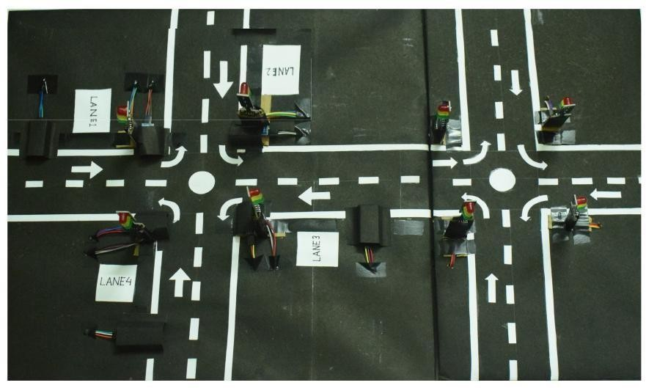

MODEL OF THE PROJECT